**👥 Managing Users and Permissions in Splunk**

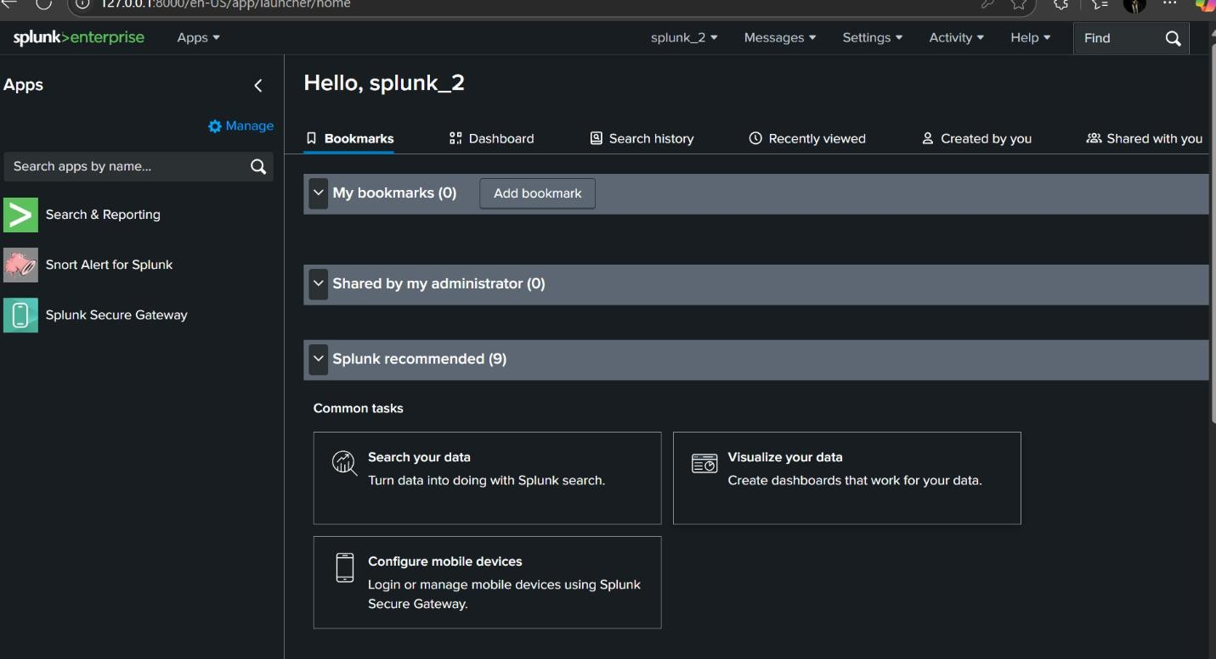

Pçt **Getting Started with Splunk User Management - Step 1**

First step: Log in to the Splunk portal to begin the process of adding a new user. Efficient access control starts with proper user setup! _ □¿˙x+

## ☼O◦ User Creation in Splunk – Step 2

After accessing the portal, head over to the **Settings** tab and choose **Users** to initiate the creation of a new user.

Managing access effectively is key to secure operations! º.t +

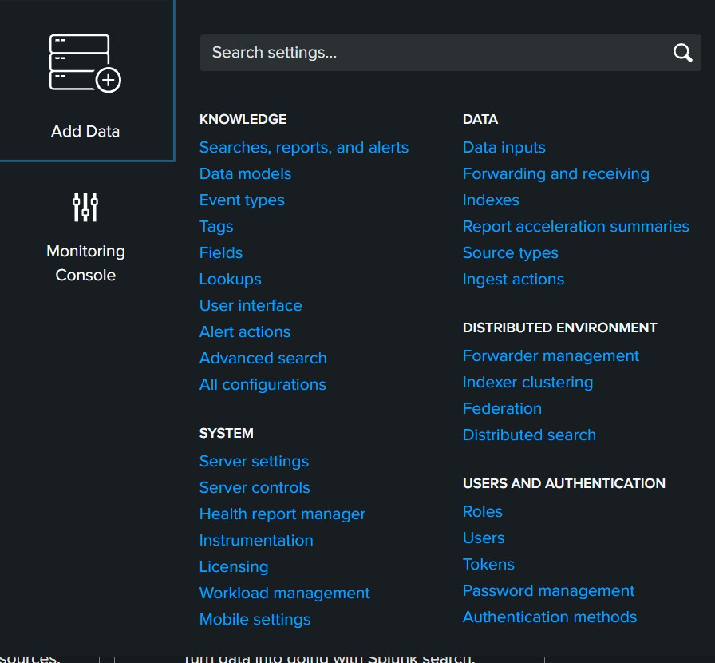

## †ç, Splunk User Management – Step 3

Click on **Add User**, assign the necessary roles and specify the index access permissions.

Finalize the setup to successfully create the new user in Splunk. ⬛ çt'P

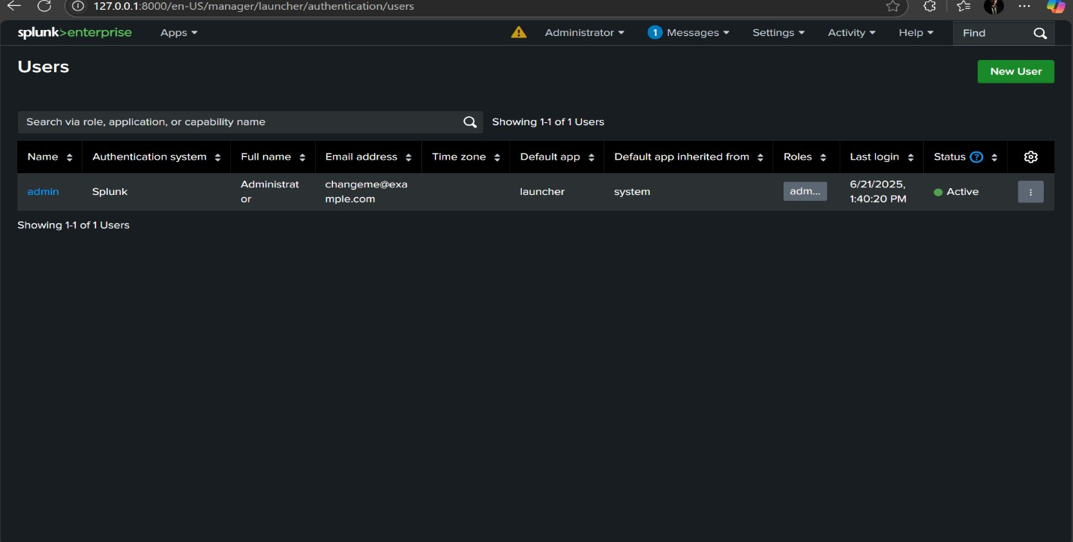

# •¸ )‘ Splunk User Management – Step 4

Enter all necessary user details as required by Splunk to ensure successful account creation.

Accuracy in user configuration enhances system security and access control.

çt'P−–,– ¯⬛|

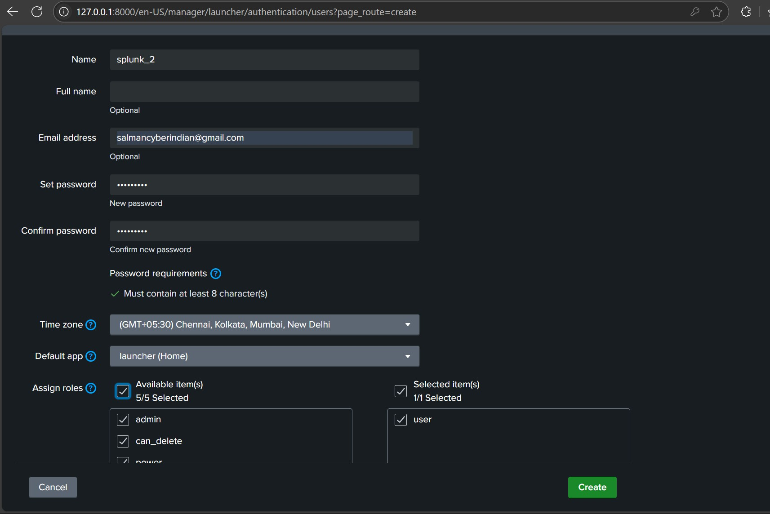

# ⬛ Splunk User Management – Step 5

After submitting the user details, the new account will be successfully created and reflected in the **User Dashboard**.

A seamless user creation process ensures better visibility and control. +ç# ¡/

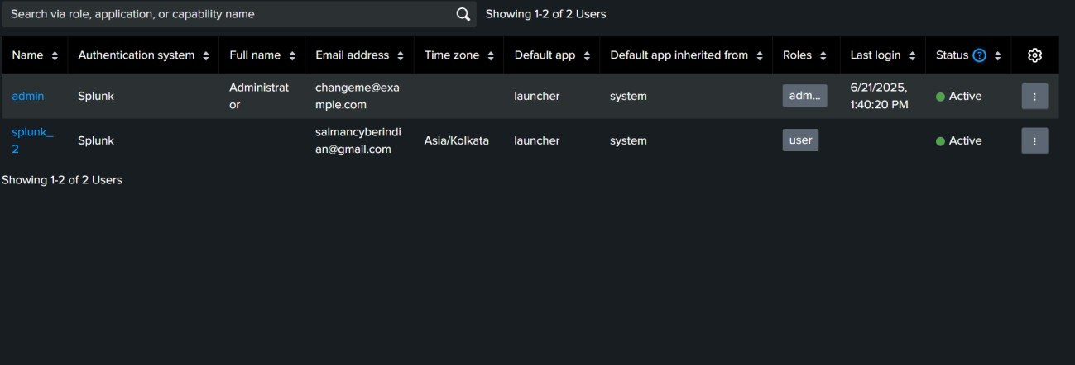

# ) Splunk User Management – Step 6

Navigate to the **Indexes** section and assign relevant permissions based on the user's role and responsibilities.

For example, provide access to indexes like:

⬛➜ summary

⬛➜ audit

⬛➜ configtracker

➜⬛ dsclient

Granting the right access ensures users can only view and work with the data they need — enhancing both security and efficiency. çPt')J

# Splunk User Management – Step 7

Within the assigned **Role Settings**, locate the **Search Jobs** window limit and set it to **Infinite**.

⬛.-' Don’t forget to **Save** the changes to ensure the configuration is applied successfully.

Optimizing search settings allows uninterrupted data access for extended investigations and monitoring. •˙Q⬛#/